DATA SCIENCE
TITLE OF THE PROJECT: Diabetes Prediction System

1. Abstract

This paper concerns the development of a Diabetes Prediction System using Django and involves integration with a machine learning model in predicting the likelihood of diabetes in people based on a combination of health metrics. Logistic regression will be used to attain such predictions. A user-friendly web interface is available to let users input their data and get predictions in real-time. The project showcases the role of predictive analytics in healthcare by integrating data science and web development in developing impactful technology solutions.

This Diabetes Prediction System aims at empowering users with necessary knowledge and tools to enable them to take proactive steps toward health management, a way that may help reduce the burden of diabetes through timely detection and intervention.

2. Table of Contents
- Abstract
- Table of Contents
- Introduction
- Existing Method
- Proposed Method with Architecture
- Methodology
- Data Collection
- Data Preprocessing
- Model Development
- Web Application Development
- Testing and Validation
- Implementation
- Conclusion

- Introduction

Diabetes is one such chronic ailment that grips millions of people all over the world and leads to serious health complications if the condition is not diagnosed and managed at an early stage in life. Machine learning, in this context, can predict the on-set of diabetes with the help of data-driven technologies, and timely interventions can be facilitated. The objective of this project is to develop a Diabetes Prediction System using Django by creating a logistic regression model and making it functional through a user-friendly web application. The system can take in measurements of various health metrics and return immediate predictions, thus enabling early diagnosis and prophylaxis.

Logistic regression is then used to identify a pattern between input variables, such as age, BMI, glucose levels, and other health indicators, assessing the probability of diabetes. A web-based application designed to reach a large part of users will provide a smooth and user-friendly interface where one can easily feed in their data and get results.

The project aims at achieving full integration of machine learning with web development, showing how these technologies can be harmonized to be impactful in healthcare. Besides, the system is developed in such a way as to provide scalability for possible future upgrades, such as adding more predictive models or health metrics.

This is a diabetes prediction system to be used in helping people live healthy lives and as proof of concept on how predictive analytics can do much more in healthcare. It is able to help in early diagnosis, allowing health providers and patients to become proactive in fighting diabetes and its associated complications by offering real-time, data-driven insights.

- Existing Method

The conventional techniques for the diagnosis of diabetes are mainly based on some clinical tests, which are as follows:

- Fasting Blood Glucose: It is the level of blood sugar after fasting.
- HB A1c Test: This is a test that will establish the average of your blood sugar levels over the past 2-3 months.
- Glucose Tolerance Test: A test that measures the body's response to glucose.

Although accurate, these methods are less user-accessible since they require visits to health facilities and laboratory analyses. Several machine learning models were proposed to predict the risk of diabetes based on health data, but many existing solutions are either constrained by poor user accessibility or suboptimal performance owing to insufficient data handling or feature engineering.

Proposed Method with Architecture
The proposed system involves the following components:
- Data Input: Users input their health metrics, including age, BMI, glucose levels, and blood pressure.
- Data Preprocessing: Input data is cleaned, normalized, and formatted appropriately for the prediction model.
- Prediction Model: The logistic regression model processes the preprocessed data to generate a prediction regarding diabetes risk.
- Web Interface: Provides a clear, user-friendly interface for data entry and displaying predictions.
- Backend: Django manages data handling, model integration, and user interactions, ensuring smooth functionality of the system.
Architecture Diagram:

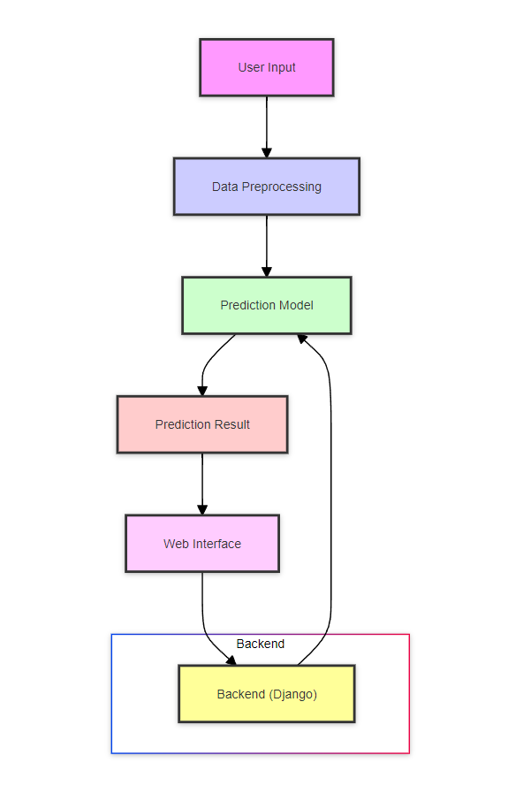

6. Methodology

Data Collection
The dataset for this project includes various health metrics from patients, such as:
- Age
- BMI
- Glucose levels
- Blood pressure
- Insulin levels
- Pregnancies
- Skin Thickness
- Diabetes Pedigree Function
Sources: Data is obtained from Pima Indians Diabetes Database available through Kaggle.

Data Preprocessing
Steps:
- Cleaning: Handle missing values through imputation or removal.
- Normalization: Standardize data to a common scale, crucial for logistic regression.
- Splitting: Divide the dataset into training and testing sets to evaluate model performance.
- Feature Scaling: Apply techniques such as Min-Max Scaling or Standardization.

Model Development
Logistic Regression Model:
- Choice Justification: Selected for its effectiveness in binary classification problems.
- Training: Train on preprocessed data with applied regularization to avoid overfitting.
- Evaluation Metrics: Assess model performance using accuracy, precision, recall, and AUC-ROC curve.

Web Application Development
Using Django:
- Frontend Development: Create input forms and result display pages using HTML, CSS, and Bootstrap for an attractive, responsive design.
- Backend Development: Integrate the logistic regression model with Django views and templates to process user input and return predictions.

Testing and Validation
Testing:
- Model Testing: Evaluate accuracy, precision, recall, and AUC-ROC on the test dataset.
- Web Application Testing: Conduct usability tests and check responsiveness across different devices.
Validation:
- Cross-Validation: Use techniques like k-fold cross-validation to ensure model robustness.

7. Implementation

Environment Setup
- Tools: Install Python, Django, Pandas, NumPy, Scikit-learn, and other required libraries.

Model Training
- Training: Train the logistic regression model on the training dataset with tuned hyperparameters for optimal performance.

Web Development
- Frontend: Develop using Django templates, HTML, CSS, and Bootstrap.
- Backend: Implement Django views to handle data processing and prediction integration.

Integration
- Model Integration: Connect the trained model with Django backend to process user inputs and display predictions.
Libraries and Versions Information:
- TensorFlow: 2.0
- Pandas: 1.5
- NumPy: 1.23
- scikit-learn: 1.2
- Django: 4.1
- Matplotlib: 3.6
- Seaborn: 0.12

8. Conclusion
The Diabetes Prediction System exemplifies the integration of machine learning with web development to create a practical tool for assessing diabetes risk. By offering an accessible and user-friendly interface, this system facilitates early diagnosis and encourages proactive health management. Future improvements could focus on enhancing model accuracy through the incorporation of more sophisticated algorithms and broadening the dataset to encompass more diverse populations. This project underscores the transformative potential of predictive analytics in healthcare, highlighting the pivotal role of technology in improving patient outcomes.

Presented By: Shreyas Pawaskar

